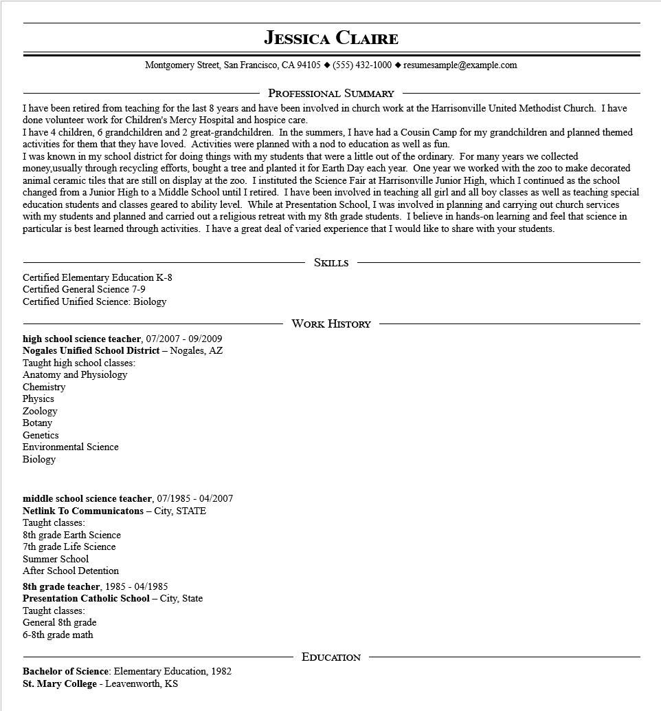
JESSICA CLAIRE
Montgomery Street, San Francisco, CA 94105 ♦ (555) 432-1000 resumesample@example.com
PROFESSIONAL SUMMARY
I have been retired from teaching for the last 8 years and have been involved in church work at the Harrisonville United Methodist Church. I have done volunteer work for Children's Mercy Hospital and hospice care.
I have 4 children, 6 grandchildren and 2 great-grandchildren. In the summers, I have had a Cousin Camp for my grandchildren and planned themed activities for them that they have loved. Activities were planned with a nod to education as well as fun.
I was known in my school district for doing things with my students that were a little out of the ordinary. For many years we collected money,usually through recycling efforts, bought a tree and planted it for Earth Day each year. One year we worked with the zoo to make decorated animal ceramic tiles that are still on display at the zoo. I instituted the Science Fair at Harrisonville Junior High, which I continued as the school changed from a Junior High to a Middle School until I retired. I have been involved in teaching all girl and all boy classes as well as teaching special education students and classes geared to ability level. While at Presentation School, I was involved in planning and carrying out church services with my students and planned and carried out a religious retreat with my 8th grade students. I believe in hands-on learning and feel that science in particular is best learned through activities. I have a great deal of varied experience that I would like to share with your students.
Certified Elementary Education K-8
Certified General Science 7-9
Certified Unified Science: Biology
SKILLS
high school science teacher, 07/2007 - 09/2009
Nogales Unified School District - Nogales, AZ Taught high school classes:
Anatomy and Physiology
WORK HISTORY
Chemistry
Physics
Zoology
Botany
Genetics
Environmental Science
Biology
middle school science teacher, 07/1985 - 04/2007
Netlink To Communicatons - City, STATE
Taught classes:
8th grade Earth Science
7th grade Life Science
Summer School
After School Detention
8th grade teacher, 1985 - 04/1985
Presentation Catholic School - City, State
Taught classes:
General 8th grade
6-8th grade math
Bachelor of Science: Elementary Education, 1982 St. Mary College - Leavenworth, KS
EDUCATION

